VERSION HISTORY
VER. | VERSION DETAIL/S | AUTHORED BY: | APPROVED BY: | DATE APPROVED
1.0 | Agreed and SIGNED OFF Guidelines | Indra | Globe ISG | 12/20/2019

DOCUMENT UPDATE HANDLING

The RPA CoE Core team will have a quarterly cadence in order to evolve the documents and to improve the guidelines based on the experiences from previous quarter. The document will have the same people assigned to review and sign-off. In case there are changes in the approvers, the new person assigned to review and update the document must be listed in the version control table of the document

Table of Contents

1. Introduction 4
1.1. Purpose 4
1.2. Scope 4
1.3. Audience 4
1.4. Glossary 5
1.5. Tools 5
2. Infrastructure Flow Map 6
2.1. Current State versus End State 6
3. Infrastructure Design 8
3.1. Current State 8
3.1.1. Development Environment 8
3.1.2. Testing Environment 10
3.1.3. Production Environment 10
3.1.4. Reporting and Monitoring 11
3.1.5. Firewall 11
3.2. End State 12
3.2.1. Firewall 12
3.2.2. Environment Separation 12
3.2.3. Code Versioning 13
3.2.4. Development Environment 13
3.2.5. Testing Environment 14
3.2.6. Production Environment 14
3.2.7. Reporting and Monitoring 16
4. Infrastructure Implementation 17
4.1. Current State 17
4.1.1. Team 17
4.1.2. Resource Deployment 17
4.1.3. UiPath Version Upgrade 19
4.1.4. Knowledge Managment 19
4.2. End State 20
4.2.1. Team 20
4.2.2. Resource Deployment 20
4.2.3. UiPath Version Upgrade 20
4.2.4. Knowledge Managment 21
5. Infrastructure Support & Operation 22
6. APPENDIX 23
6.1. Usefull Links 23

Introduction

Purpose

The purpose of this document is to consolidate all the information regarding the infrastructure needs required for the technological tools used for the automation of processes and their hardware requirements.
This document will allow the reader to understand, in general terms, what the RPA infrastructure is and how it works. Covering design and implementation phases, both currently in place and recommended end state. The operations phase is covered by the Support and Operations document, part of the guidelines of this CoE.
The recommendations for the End-state included in this text must be followed in order to achieve an efficient and functional infrastructure.
Modifications and adaptations of the infrastructure may be required at the local level for the proper functioning of the tool. These adaptations must be clearly identified and evaluated by the Local Architecture team, with the support of the Global teams.

Scope
The scope of this document is global, encompassing the infrastructure for all the RPA program, serving as a guide for the infrastructure architect of the operator to carry out the technical design and implementation of the solution and the request for the necessary equipment and interconnections.

Audience

This document is directed to the following roles:
- Obligatory:
  - Service Delivery Manager/DevOps Coach
  - DevOps Engineer
  - Infra Squad Ops (or Infra Design and Infra Implem)
  - RPA Support & Ops Team
  - Platform SDM
  - Solution Designer
  - Developer Lead
  - Product Owner
- Recommended:
  - Developers
  - Continuous Improvement Manager

Glossary

Tec Reco | The “Enterprise RPA Tech Reco v11082019” document.
Git | GitHub at https://github.com/
TFS | Team Foundation Version control, currently named Azure DevOps Server
SVN | Subversion at http://subversion.apache.org/
VM | Virtual Machine in some contexts interchangeable with Robot
ES | Elastic Stack, for the context of this document is comprised of Elastic Search + Kibana
PDD | Process Definition Document

Tools

The tools covered in this document are:
- UiPath Platform 2018.4 for RPA development and execution
- Elastic Search and Kibana for business report production

UiPath is an RPA platform with three main components:
- UiPath Studio – it is a tool that allows to automate a process, implementing the functionally defined process in a informatics process in a visual and/or coded computer language
- UiPath Robot - executes the processes developed in the Studio. Always requires a machine to run, either virtual or physical, these machines are usually designated clients. There are two types, the attended and the unattended robots, the first one can be controlled remotely and programed to start and stop at any time, the later require direct human intervention to start their execution.
- UiPath Orchestrator - is a web based control panel, designed to monitor, log and control the execution of an N number of Robots on client computers. It can start stop, and program schedules for unattended robots to run.

Elastic Search and Kibana form a stack of tools that work together to ingest, treat data and display reports.
Elastic Search is the engine that can ingest structured and semi-structured data using the available tools to parse, normalize and enrich data from an array of data sources, including logs, system and web applications metrics and business metrics. This data can then be consulted and produce reports.
Kibana, is the display layer that will be used to design, create the dashboards and display the data in real-time.

Infrastructure Flow Map
This document covers infrastructure design and implementation stages. The operations stage is covered in detail in the Operations and Support document, part of this CoE guidelines.
For each one of the stages design and implementation, there is a definition of the (1) current state and a proposal for the (2) end state, which is the recommended approach.
The following chapters can be used by the used as a guide to the document.

Current State versus End State

The current state chapters throughout this document contain the procedures and infrastructure configurations in place. The current state might not be ideal or recommended, and is currently in place as consequence of a variety of factors (i.e. tight budget, change management delays, etc). Documenting it is important in order to guarantee that the program can follow a set of procedures that are well established and fully agreed between the counterparts.
The end state chapters throughout this document contain the recommended procedures and infrastructure configurations. Documenting it is important in order to guarantee that the program can have a defined set of best practices and aim to achieve them.
The following table highlights the main differences between both:
 | Current State |  | End State
 | Definition | Chapter | Definition | Chapter
Development Machines Type | Physical and Virtual Machines | 3.1.1 Development Environment | Virtual Machines | 3.2.4 Development Environment
Environment Separation | No Environment Separation | - | -Separation between Development and Production  -Creation of testing environments | 3.2.2 Environment Separation  3.2.5Testing Environment
Code Versioning | No code versioning software | - | Code Versioning software | 3.2.3 Code Versioning
Firewall | Manual Setup | 3.1.5 Firewall | Automatic Setup | 3.2.1 Firewall
Infraestructure Team | Current Globe structure | 4.1.1 Team | Dedicated team | 4.2.1 Team
UiPath Version Upgrade | No procedure defined | 4.1.3 UiPath Version Upgrade | Defined Procedure | 4.2.3 UiPath Version Upgrade
Knowledge Management | No procedure defined | 4.1.4 Knowledge Managment | Use KMS capabilities of current ITSM software | 4.2.4 Knowledge Managment

The following flow chart maps the defined process for all infrastructure procedures. This process is common between current and end state.

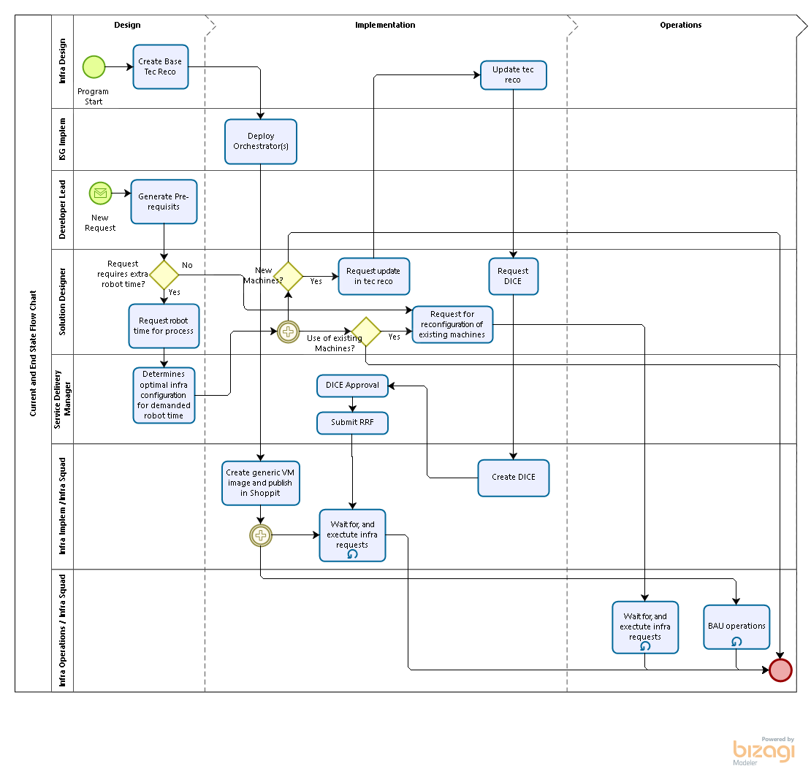
(Note: For the more detail on how the process flow join with the end to end process, please refer to the “Governance” document.)

Infrastructure Design

Current State

The current enterprise RPA infrastructure is defined in the Technical Recommendation document, named “Enterprise RPA Tech Reco v11082019”. This document covers the following:
- High-level logical diagram High Availability
- High-level High Availability Infrastructure diagram
- High-level Network Diagram
- Hardware and Software Requirements
- Systems which robot(s) will be given credentials and access
- Capacity Projection: Bandwidth requirement
- Assorted Assumption
- Disaster Recovery Requirement
- Test Environment Requirement
- Development Environment Requirement
- Backup Requirements
- Proposed Infrastructure Design
- Production Infrastructure Components
- Other Infrastructure Components
- 3rd party licenses
- Server Connection Matrix
- Network Segmentation
- Network Diagram

Development Environment

The current technical recommendation document “Enterprise RPA Tech Reco v11082019”, does not define the procedure to supply the developers with the UiPath Studio and Studio licenses access to the target applications.
Licenses for UiPath Studio should always be requested through ISG.
For the UiPath Studio access, there are currently two options.
- Physical Machines: Developers use physical machines with a locally installed Studio to develop. These machines must be registered in Globe network, and for most of the cases physically located at Globe’s premises in order to allow access to the required target applications.
Pros:
- Reduction of cost in not having to pay cloud service for hosting VMs for developing.
- Reduction of cost in remote access tools
Cons:
- Creation of delays when onboarding new developing resources, by requesting configurations of the physical machines that may be time consuming
- Cumbersome procedure to off board developers
- Requiring access and space in the Globe premises to house the developers
- Not allowing development to be outsourced to outside of the country
- Security concerns by handing machines with Globes network configuration and access (a lost laptop can create problems)
- Difficulty in guaranteeing that machine size, OS and network configuration of the DEV environment is the same as in PROD

- Virtual Machines: Developers use virtual machines hosted in the current cloud infrastructure/network which are requested through ISG. The access to a machine is done via a remote access application.
Pros:
- Fast onboarding of new developers by spawning a new DEV VM
- Streamlined, secure and efficient procedure to off board developers
- Development can be done from any place in the world
- Easy to guarantee that machine size, OS and network configuration is the same across all environments
- Higher security
Cons:
- Cost with extra cloud infra
- Cost with extra remote access licenses

- Responsible for creation of the baseline Tech Reco for generic Studio?
- Responsible for creation of the baseline DICE for generic Studio?
(Note: This section will be updated once the signatories are identified. To be finalized by Globe.

Testing Environment

A pre-production environment is non-existent as per current technical recommendation document, “Enterprise RPA Tech Reco v11082019”.

Production Environment

The production environment is composed of the UiPath Orchestrator and Robots. The current Orchestrator and Robot configuration and sizing is defined in the technical recommendation document, “Enterprise RPA Tech Reco v11082019” and “Enterprise Robotic Process Automation – Solution Plan Doc. No.: CMMI-ISG-TM-001”

Orchestrator Server Size

Current orchestrator server is setup to support 200 robots, following UiPath recommended specifications. The performance of the machine will be monitored using Splunk and follow the BAU process already setup in Globe, and adjustments in the machine done accordingly is responsibility of the Service Delivery Manager, consulting the Platform Manager.
For more details, please refer to the “Guidelines for Operations and Support” document of this CoE.

Orchestrator Access Control

Access control in the production environment is of utmost importance. Several business units will have access to the same Orchestrator, and measures should be put in place to avoid any negative interference in the processes.
For UiPath version 2018.4, the current in place in Globe, the recommended approach to achieve access control, is to have a tenant per business unit. Tenants will have their own individually attributed licenses that cannot be shared with other tenants. For more information about tenant management please refer to UiPath documentation, please refer to the web link in Appendix, at chapter 6.1 Usefull Links.
The UiPath version 2019.10.1 allows access control at the folder level. That functionality makes it possible to have licenses at the Orchestrator level, that can be shared between business units, therefore achieving higher efficiency in its utilization while maintaining access control.

Network Segmentation

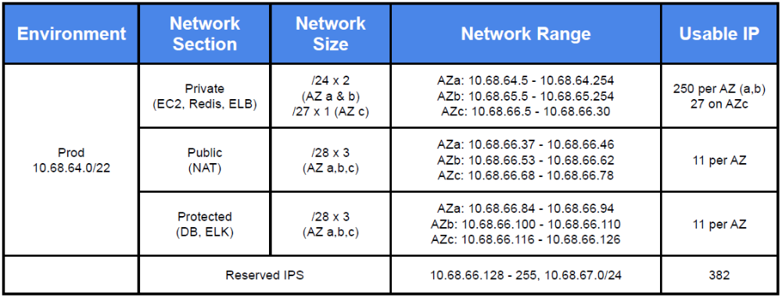
  - Responsible for creation of the baseline Tech Reco for generic Robots?
  - Responsible for creation of the baseline DICE for generic Robots?
(Note: This section will be updated once the signatories are identified. To be finalized by Globe.

Reporting and Monitoring

It is highly recommend using Elastic Search and Kibana (Elastic stack, or ES) for reports at RPA application level only. For reporting and monitoring at all other levels i.e. infrastructure, network, etc.; it should be used Globe’s current BAU process, namely using Splunk. More details in the Support and Operation document.
Recommend applications for the Elastic Stack:
- Produce automatic reports for business, according to the identified need in the PDD
- Produce automatic reports on the usage of licenses to charge back costs to the different business units
- Produce automatic reports on the current efficiency rate in the usage of the licenses.

Firewall

Request

The request for a firewall configuration should be automatically launched internally, every time one of the following requests is received by the infra team:
- New machine deployment
- New application installed/access to application requested in a machine
The development and team should not be required to make the firewall configuration requests, because the process and configuration itself is not transparent outside of Globe’s infrastructure and network teams.

Configuration

The firewall configuration should be determined based on:
- The process requirements – the type and number of target applications the processes requires
- Globe’s Internal definition and best practices
- Vender recommendations by UiPath vendor, as shown below:
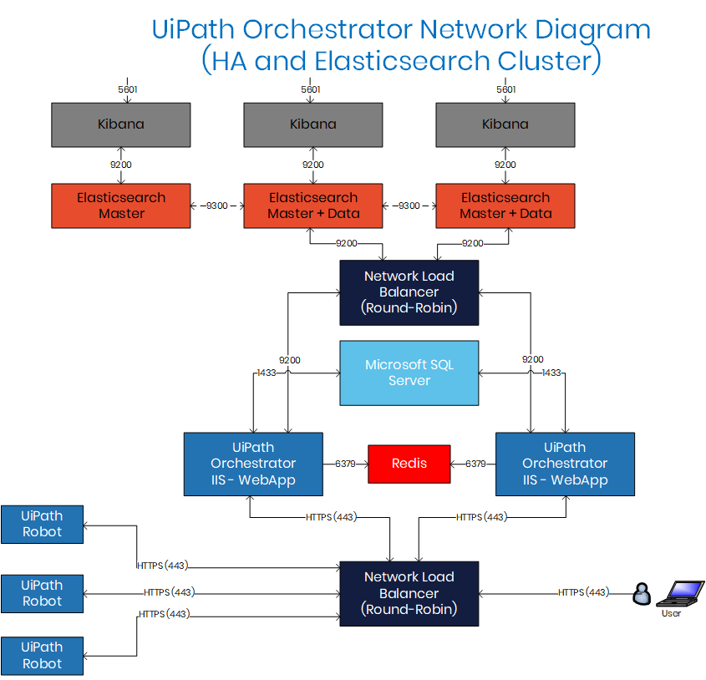
All rights reserved UiPath 2019. From: https://docs.uipath.com/orchestrator/docs/configuring-the-firewall

Setup

The procedure for the actual setup of the firewall is currently done manually.

End State

Firewall

Request and configuration

The procedure for requesting, and determining the configuration is the same as defined in 3.1.5 Firewall .

Setup

The procedure for the actual setup of the firewall is recommended to be updated in order replicated automatically, but under the control of the dedicated infrastructure team, in the machines all selected for the configuration.

Environment Separation

The UiPath Orchestrator database stores all the information regarding the robots, assets and the environment it is executing, because of this, it is a recommendation from the UiPath vendor to have separate orchestrator and database for each environment.
The current infrastructure as per defined in the Tec Reco document does not fulfil the environment separation recommendation, having only one Orchestrator (and DB layer) for both development and production environment.
The recommended environments are be:
-Development and Testing (Unit and Integration)
-Pre-production (UAT & Regression) and Production
When there is an environment separation, a code versioning software will be the bridge between DEV and PROD environments. Every time a developed process is to be delivered for deploy into production, the developers cannot publish it using the Orchestrator connected to their Studio. A package should be produced and loaded to the code versioning tool, followed by a Release Notes document. The operation team will have access to the versioning software and use the packaged for the necessary procedures.
Having an environment separation will allow the testing of any upgrade or configuration of the RPA software stack in the development environment prior to rollout in production.

Code Versioning

All code developed should be stored and versioned, especially the versions deployed in production.
This allows:
- Traceability
- Fast rollbacks to any previous version
- Bug detection using the File Diff feature

UiPath is natively compatible with Git, TFS and SVN. The tool to be used should be chosen after an internal analysis. When there is an environment separation, the code versioning software will be the bridge between DEV and PROD environments.

Development Environment

Please refer to chapter 3.1.1 Development Environment for the current state. The end state recommendation is for development to be done in virtual machines only; the machines should be requested through ISG, with the costs being passed to the respective Business Domain/Unit.
Licenses for UiPath Studio should always be requested through ISG.

Tenancy

It is recommend to have a development environment as similar to production as possible. In terms of tenancy division, and any other relevant configuration that can be mimicked like access to same application versions in dev or test version.

  - Responsible for creation of the baseline Tech Reco for generic Studio?
  - Responsible for creation of the baseline DICE for generic Studio?
(Note: This section will be updated once the signatories are identified. To be finalized by Globe.

Testing Environment

It is mandatory to have testing environments. This should be done at both the RPA software level (Orchestrator and Studio) and Target Applications level.

RPA software

The recommended environments to be created in UiPath are:
- Development and Testing – For the context of this chapter this environment will specifically support unit and integration testing during development.
- Pre-production and Production – For the context of this chapter this environment will specifically support regression and user acceptance testing.
Having two orchestrators, for Development and Production environment, the testing environments can be easily created using the “Creating a New Environment” tool in the UiPath Orchestrator.
The environments should consist of a number of VMs, that will vary based on the demand at any specific moment, and can be easily adjusted at the “Environments tab” in UiPath Orchestrator.

Target Applications

All the Target Applications (applications involved in each process), must have a QA environment, which closely resembles the production environment, in terms of:
- Application version
- Available datasets
This is the version “against” with all the development and testing, prior to the UAT should be done.
The application administrator is responsible for providing and configuring the QA version; And the business team involved responsible for providing guidance on the dataset to load in the QA version. This version should then be made available to the development, support and operations team.

Production Environment

  - Responsible for creation of the baseline Tech Reco for generic Robots?
  - Responsible for creation of the baseline DICE for generic Robots?
(Note: This section will be updated once the signatories are identified. To be finalized by Globe.

Virtual Machines Size

The production environment is composed of the UiPath Orchestrator and Robots.

Orchestrator

The current Orchestrator configuration and sizing defined in the “Enterprise RPA Tech Reco v11082019”, is aligned with the recommendation.

Robots

Initial considerations:
The Robots (VMs) sizing, defined in the “Enterprise RPA Tech Reco v11082019”, using lower and upper boundary as specified by the UiPath vendor, does not provide a specific VM size or methodology for its calculation. This chapter addresses this matter.
Considerations about VM sizing:
- Allowing only one VM size highly bloats the infrastructure costs, since, for the chosen size to accommodate the highest requirements process, it would be oversized for other processes.
- On the other end, allowing the sizing of the VMs on a per process basis, would not maximize the savings either, since it would be very complex match the processes in order to use the full 24h processing time available per VM. Also, the fact that for each VM size, a new tec reco must be done; will create large delays in the operation.
The recommend approach is to have only two different VM sizes that can accommodate 99.9% of the processes. This will allow to:
- Reduce infrastructure costs by adjust the rented processing power to the processes needs
- Reduce infrastructure costs by adjusting the rented processing time to the processes needs
- Reduce the time to deploy processes in production by having predefined and pre-approved machine sizes
- Require creation of tec recos only for very special cases

The recommended sizes are:
Date |  | Size 1 | Size 2
November 2019 | CPU | 2 x 2.4GHz 64-bit (x64 or x84 if application requires) | 4 x 2.4GHz 64-bit (x64 or x84 if application requires)
November 2019 | RAM | 4 GB | 8 GB
November 2019 | DISK | 100 GB | 100 GB
November 2019 | Notes | Recommended for processes with target applications that run on thin clients or are web | Recommended for processes with target applications that run on thick clients or are desktop

Methodology for size calculation:

The recommended machine size will depend solely on the processing load of the applications involved in the process, since UiPath and operative system is a common factor in all.
The recommended approach is to select:
- Size 1, for all processes with web based or thin client desktop applications
- Size 2, for all processes with at least one thick client application

The recommend sizes should be kept up-to-date during the RPA Program, as the applications requirements evolve or change. This is a direct application of the continuous improvement process defined in the Governance Model document.
Whenever it is determined, that either sizes, as currently defined in the table are not able to fulfill the application needs; they should be updated. Change of a machine size from size 1 to size 2 should be done only in case the process requirements change and match the conditions defined for size 2. All VMs in production with available processing capacity should also be upgraded for the newly defined size. The historical records should be maintained in the table above, in conjunction with the updated ones.

Network Connection Sizing

Since the infrastructure is cloud based, both processing capacity and bandwidth are rented; this is a resource that should be managed in order to achieve cost savings.
As defined in the current “Enterprise RPA Tech Reco v11082019”, there an initial 25Mbps bandwidth channel available for the RPA Program. As a consequence there is no need to pre-determine the consumption of bandwidth of each process prior to each individual deployment into production.
This is the recommended approach to follow, is to monitor the bandwidth consumption of the robotic farms, to allow for a timely request of more bandwidth allocation whenever the currently available reaches an 90% threshold of peak utilization, or 80% average utilization.
The monitoring of the network will be done using Splunk and will follow the BAU process already setup in Globe. For more details, please refer to the “Guidelines for Operations and Support” document of this CoE.

Generic Virtual Machine Image

All robots should be spawned using a pre-approved Amazon Machine Image (AMI), created by the Infra Squad, and plublished in Shoppit. This has the following advantages:
- Faster setup time
- Pre-approved configuration from budget (software licenses) as well as security (firewalls configuration, applications installed) perspective.
The recommended image should have the following software stack installed/configured access to the following web applications:
- Operative System
- Browsers: Internet explorer, Firefox, Chrome and Microsoft Edge
- UiPath robot
- Security Agents

Orchestrator Access Control

Access control in the production environment is of utmost importance. Several business units will have access to the same Orchestrator, and measures should be put in place to avoid any negative interference in the processes. The current state approach is recommend for end state, more details in chapter 3.1.3 Production Environment, subchapter Orchestrator Access Control.

Reporting and Monitoring

As recommended in chapter 3.1.3 Production Environment.

Infrastructure Implementation

Current State

Team

The creation of any infrastructure request (i.e. provisioning, configurations, upgrades, etc.):
- Prior to a robot being in production stage, should be done by the Solution Designer.
- Once a robot is in production stage, are the responsibility of the Support and Operation Team. Since they are responsible for guaranteeing its correct execution and operation.
The handling and fulfillment of these requests must be accomplish by the current team structure in Globe for all the infrastructure activities, from design to implementation and operations.
This model will be used from the start of the initiative, while the demand is low and the current structure can absorb it.

Resource Deployment

Orchestrator

Installation
The initial installation of the Orchestrator was responsibility of the ISG delivery team. Further changes in the installation of the orchestrator, such as upgrades, reinstallation or configuration are responsibility of the Applications Operations team.

Robots

The infra requirements of each new process should be evaluated by the DevOps Coach/Service Delivery Manager, with consultation from Platform SDM(s) and the Product Owner involved in the process development, in order to determine if the current robotic farm of the tenant in question can support the deployment of the new process or an additional robots must be created. If the analysis concludes some machines need to be re-used, the Process Owners of processes that run in those machines should also be consulted.
This will guarantee maximum efficiency in the use of the resources, and cost savings.
Tenant 1
[Business Unit]
Globe’s Orchestratror
Robot 1
Size: 1 or 2
Usage Window: [Hour, Periodicity]
Applications: [List]
Web Accesses: [List]
Robot 2

[Information]
Robot N

[Information]
…
Robot 1
[Information]
Robot 2

[Information]
Robot N

[Information]
…
Robot 3

[Information]
Robot 1
[Information]
Robot 2

[Information]
Robot N

[Information]
…
Robot 3

[Information]
…
Tenant 2
[Business Unit]
Tenant N
[Business Unit]
Using the following information for each machine in the current production infrastructure, stored in the Configuration Items (CI) in Globe’s ITSM platform (Remedy):
- (Attribute 1) Machine size
- (Attribute 2) Applications Installed
- (Attribute 3) Web Accesses
- (Attribute 4) Current Scheduled Processes
In addition, the following information about the process to deploy:
- (Attribute 5) Total execution time per day/week/month (depending on the process periodicity)
- (Attribute 6) Applications used
- (Attribute 7) Web Accesses required
- (Attribute 8) Tenant to receive the process.
- (Attribute 9) If any application used is incompatible with execution in dedicated or shared AWS servers

The evaluation process should be as follows:
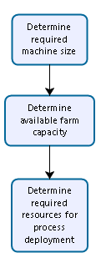
- Determine required machine size – attribute 9 - following the guidelines documented in this document chapter 3.2.6 Production Environment
- Determine available farm capacity:
  - Single out robots of the selected tenant (attribute 8)
  - Filter machines by machine size (attribute 9)
  - Calculate total available execution time in the selected machines (attribute 10), using attribute 4
  - Determine if the total execution time of the process (attribute 5) exceeds current available execution time (attribute 10).
- Determine required resources for process deployment
  - If available execution time exceeds the execution time of the process, proceed to map the execution of the process in the available machines, by defining schedules and requests for applications and web accesses using attributes 2, 3, 6 and 7
  - If the available execution time is not enough to cover the execution time of the process, proceed to:
    - Define the number of additional machines required with their respective configuration: machine size, schedules and requests for additional applications and web accesses using attributes 2, 3, 6 and 7
    - If applies, map the execution of the process in the available machines by defining schedules and requests for additional applications and web accesses using attributes 2, 3, 6 and 7.

The deployment of each new VM must be done according to the following procedure:
- Deploy using the generic virtual image available in Shoppit using the requested machine size
- Join Virtual Machine into Globe’s Domain
- Install and configure required applications
- Configure required Web Accesses
- Execute Security Risk Assessment
- If the request is for more than one VM with the same configuration, it is recommended that, all VMs are spawned from a copy of the first correctly configured VM.

UiPath Version Upgrade

There no procedure currently defined for UiPath Orchestrator or Studio version upgrade.

Knowledge Managment

Currently there is no procedure defined for knowledge management in regards to infrastructure management, neither the RPA CoE context as a whole.

End State

Team

The creation of any infrastructure request:
- Prior to a robot being in production stage, should be done by the Solution Designer.
- Once a robot is in production stage are the responsibility of the Support and Operation Team. Since they are responsible for guaranteeing its correct execution and operation.

The handling and fulfillment of all infrastructure requests, is responsibility of a dedicated infrastructure team, the Infra Squad. This model will apply as soon as the demand increases and the currently shared infrastructure team is not able to absord with the demand. In addition, the dedicated team dimension should be adjusted and refine according to the demand.

The Infra Squad will be responsible for all the infrastructure activities, from design to implementation and operations. The Infra Squad is a multidisciplinary team composed of:
- Infra architect
- Network Architect
- SYS admin
- DBA
- FW
- Network Implem Engineer
- TIS Lead

Resource Deployment

Orchestrator

Installation
The initial installation of the Orchestrator was responsibility of the ISG delivery team. Further changes in the installation of the orchestrator, such as upgrades, reinstallation or configuration are responsibility of the Applications Operations team.

Robot

Recommended end state of procedure for resources deployment is in line with the current, as defined in chapter 4.1.2 Resource Deployment.

UiPath Version Upgrade

RPA software may require version upgrade for either the studios or the orchestrators.

UiPath Studio Upgrade

A first check should be taken when upgrading the UiPath Studios to guarantee compatibility with the current Orchestrator version. The upgrade of Studios is done at a developer’s machine level, and should not affect the environments, so minor impact is expected.
The procedure to follow should be the one recommend by the vendor, for the specific final UiPath version please refer to the web link in Appendix, at chapter 6.1 Usefull Links.

UiPath Orchestrator Upgrade

A Uipath Orchestrator version upgrade can have a major impact in all the environments so the recommendations done by the vendor for the final UiPath version should be strictly followed, in regards to:
- Backwards compatibility with the current processes in production, studio versions, and any other software currently in use.
- Hardware requirements
- Installation procedure

The upgrade of the current environments should be done in the following order:
  - Prepare rollback plan for development’s Orchestrator version upgrade (should include save current server image)
  - Prepare testing procedure to guarantee development’s Orchestrator after version upgrade
  - Upgrade development’s Orchestrator out of developer working hours
  - Test upgrade. Rollback if failed, maintain if succeeded
  - Maintain rollback plan ready for 1 weeks after upgrade, to roll back if necessary
  - After development’s Orchestrator is guaranteed stable and functional for one week start upgrade procedure in Production
  - Create new server in cloud for new Production’s Orchestrator. Install Orchestrator
  - Initiate migration of processes to new Orchestrator. Roll back if necessary, until issue is solved
  - Delete and freed previous Orchestrator server instance.

Knowledge Managment

Use KMS capability of the current Globes ITSM tool (Remedy), to documentation document all knowledge associated with infrastructure design, implementation, change or incident.
This is the responsibility of the person to which the respective Remedy ticket has been assigned.

Infrastructure Support & Operation
Please refer to the Guidelines for the Support and Operations model document for detailed information on the support and operation of the infraestructure.

APPENDIX

Usefull Links

# | Topic | Link
1 | Orchestrator Introduction | https://docs.uipath.com/orchestrator/docs/introduction
2 | Orchestrator User Interface | https://docs.uipath.com/orchestrator/docs/the-user-interface
3 | Orchestrator Dashboard | https://docs.uipath.com/orchestrator/docs/dashboard
4 | Automation Best Practices | https://docs.uipath.com/orchestrator/docs/automation-best-practices
5 | Time Synchronization | https://docs.uipath.com/orchestrator/docs/prerequisites-for-installation#section-time-synchronization
6 | Configuring the Firewall | https://docs.uipath.com/orchestrator/docs/configuring-the-firewall
7 | Creating an Index Pattern to Connect to Elasticsearch | https://docs.uipath.com/orchestrator/docs/creating-an-index-pattern-to-connect-to-elasticsearch
8 | Web Certificates | https://docs.uipath.com/orchestrator/docs/prerequisites-for-installation#section-web-certificates-ssl-certificate-
9 | Using a Certificate for the HTTPS Protocol | https://docs.uipath.com/orchestrator/docs/using-a-certificate-for-the-https-protocol
10 | High Availability | https://docs.uipath.com/orchestrator/docs/high-availability
11 | App Settings through Web.config | https://docs.uipath.com/orchestrator/docs/app-settings
12 | Logging configuration through Web.config | https://docs.uipath.com/orchestrator/docs/logging-configuration
13 | Deployment and Configuration Considerations | https://docs.uipath.com/orchestrator/docs/deployment-and-configuration-considerations
14 | Enable Windows Authentication | https://docs.uipath.com/orchestrator/docs/enabling-windows-authentication
15 | Increasing the Size Limit of Package Files | https://docs.uipath.com/orchestrator/docs/increasing-the-size-limit-of-package-files
16 | Licensing | https://docs.uipath.com/orchestrator/docs/about-licensing
17 | Activating and uploading your license | https://docs.uipath.com/orchestrator/docs/activating-and-uploading-your-license
18 | Managing your license | https://docs.uipath.com/orchestrator/docs/managing-your-licenses
19 | Updating your license | https://docs.uipath.com/orchestrator/docs/updating-your-license
20 | About System (Host) Administrator | https://docs.uipath.com/orchestrator/docs/about-host-administrators
21 | Managing Tenants | https://docs.uipath.com/orchestrator/docs/managing-tenants
22 | About Tenants | https://docs.uipath.com/orchestrator/docs/about-tenants
23 | About Tenant Settings | https://docs.uipath.com/orchestrator/docs/about-tenant-settings
24 | Install Robot | https://docs.uipath.com/robot/docs/installing-the-robot
25 | Connecting Robots to Orchestrator | - https://docs.uipath.com/robot/docs/from-orchestrator-and-the-orchestrator-settings-window  - https://docs.uipath.com/robot/docs/from-the-command-line  - https://docs.uipath.com/robot/docs/using-the-connection-string
26 | Managing Packages | - https://docs.uipath.com/orchestrator/docs/about-packages  - https://docs.uipath.com/orchestrator/docs/publishing-a-project-from-studio-to-orchestrator  - https://docs.uipath.com/orchestrator/docs/managing-packages
27 | Updating Orchestrator | https://docs.uipath.com/studio/docs/about-updating

